**ECE9047: Laboratory 3 Report**

Course Instructor: Dr. John McLeod

Student Number: 251343797

Student Name: Yuanpeng Wang

**1.**

**Description of the problem**

Complete the pseudo-randomly generated graph to ensure the wireless sensor network (WSN) is fully connected. Analyze the graph in terms of how different nodes are connected and how the WSN covers the area. Accurately draw diagrams for both the Voronoi tessellation and the Delaunay triangulation for the graph. **Evaluate the maximal breach distance** and the **maximal support distance** of the graph.

**2.**

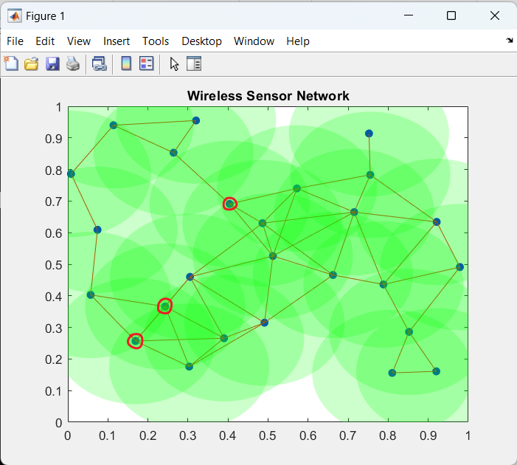

Fig. 1 The connectivity and coverage of the WSN

I added one node to ensure the WSN is fully connected. K-connectivity of the WSN is 1. The upper-left portion of the network might ‘go dark’ if the three highlighted nodes fail.

We can observe that some areas have no coverage, therefore, the K-coverage of the environment is 0.

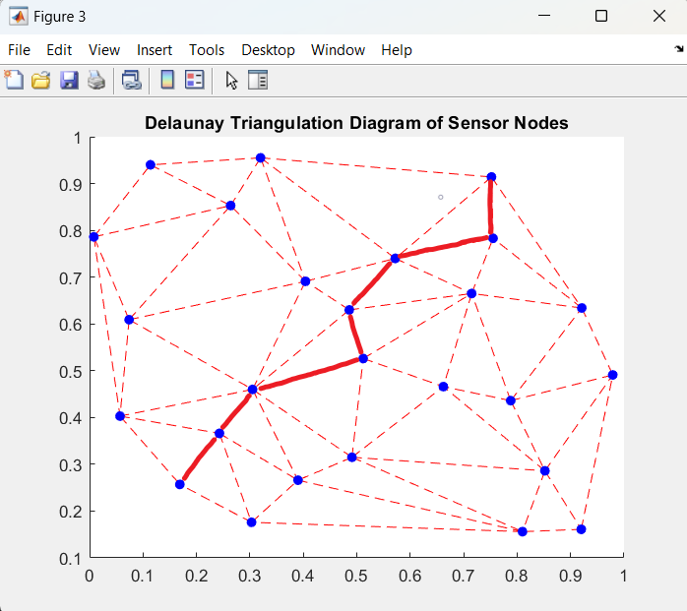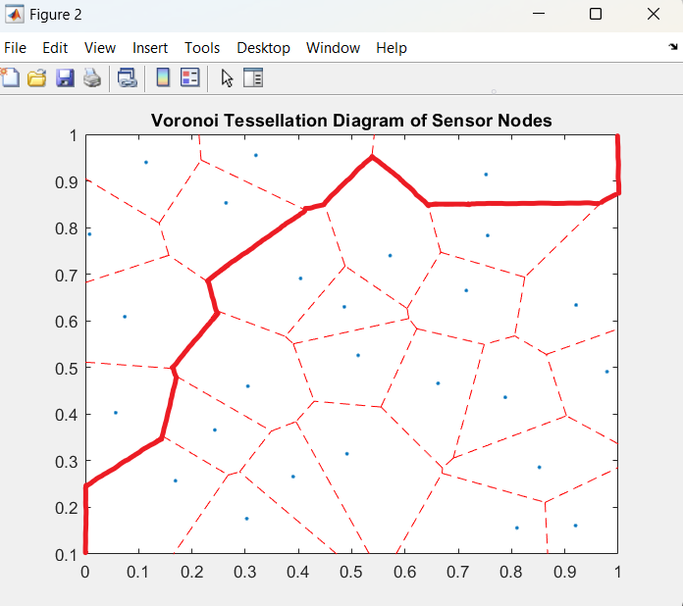**3.**

The maximal support distance

The maximal breach distance

Fig. 2 The Voronoi tessellation diagram Fig. 3 The Delaunay triangulation diagram

As we know the maximal breach path is the path that stays the furthest away from any node, which is which is highlighted on the Voronoi tessellation diagram.

For each line followed on the maximal breach path, their cost can be represented as:

$$0.092L, 0.0948L, 0.0685L, 0.1374L, 0.17L, 0.107L, 0.073L, 0.083L, 0.0639L, 0.0655L, 0.112L$$

The maximal breach distance is the smallest cost of any line followed on the maximal breach path. Therefore the maximal breach distance is 0.0639 L. It is indicated in the plot.

**4.**

The maximal support path is the path that stays closest to the nodes, which is highlighted on The Delaunay triangulation diagram.

For each line followed on the maximal support path, their cost can be represented as:

$$0.13L, 0.11L, 0.22L, 0.11L, 0.14L, 0.19L, 0.13L$$

The maximal support distance is the largest cost of any line followed on the maximal support path. Therefore the maximal support distance is 0.22 L, which is indicated in the plot.